**Excel Homework: Kickstart My Chart**

1. **Given the provided data, what are three conclusions we can draw about Kickstarter campaigns?**

* Backers - 38% of total backers were directed to the technology category, with 77% of those people leaving towards hardware.
* Starters – 34% of total starters created Theatre based initiatives, with Plays making up 26% of the grand total of all initiatives.

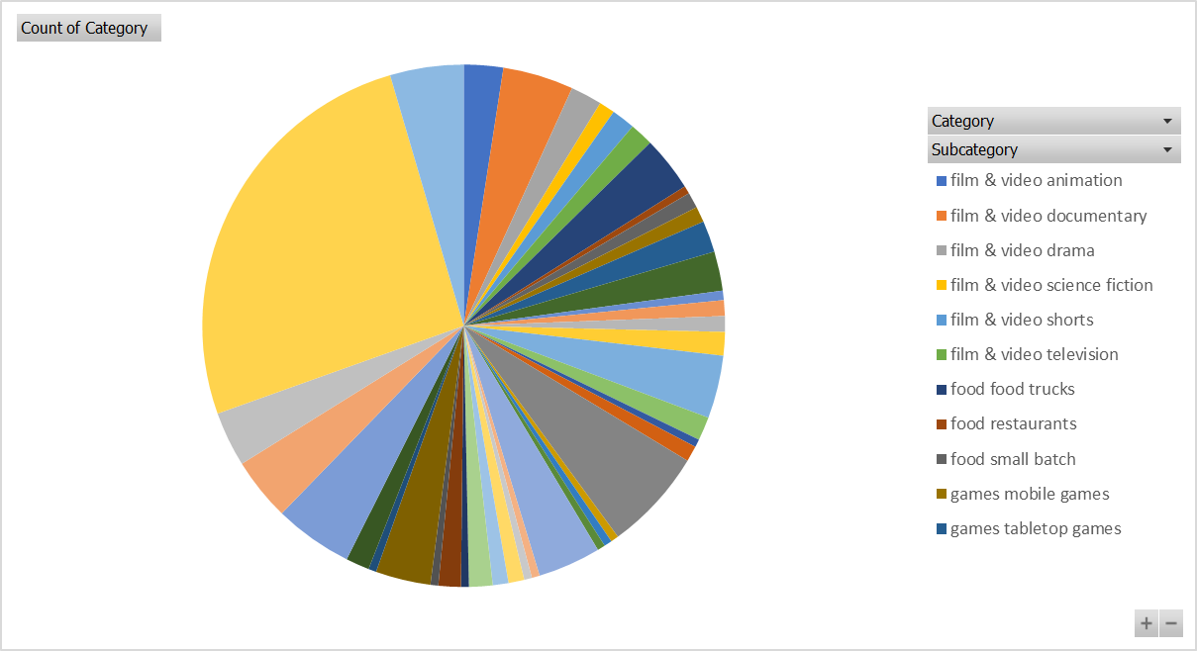

* Kickstarter campaigns were most popular between 2014 – 2017, with 77% of all campaigns being run in this period.

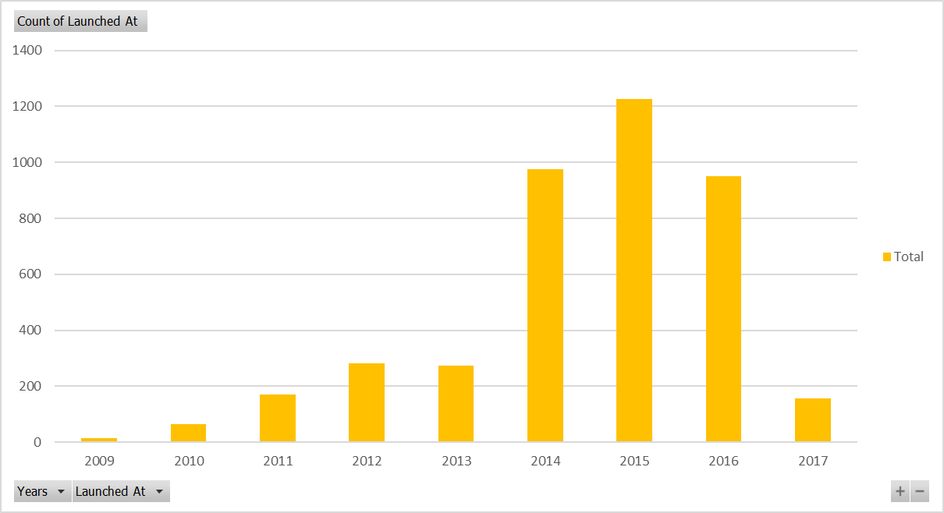

* The United States (US) was by far the most popular country for launches – with over 74% of total campaigns being started in the US.

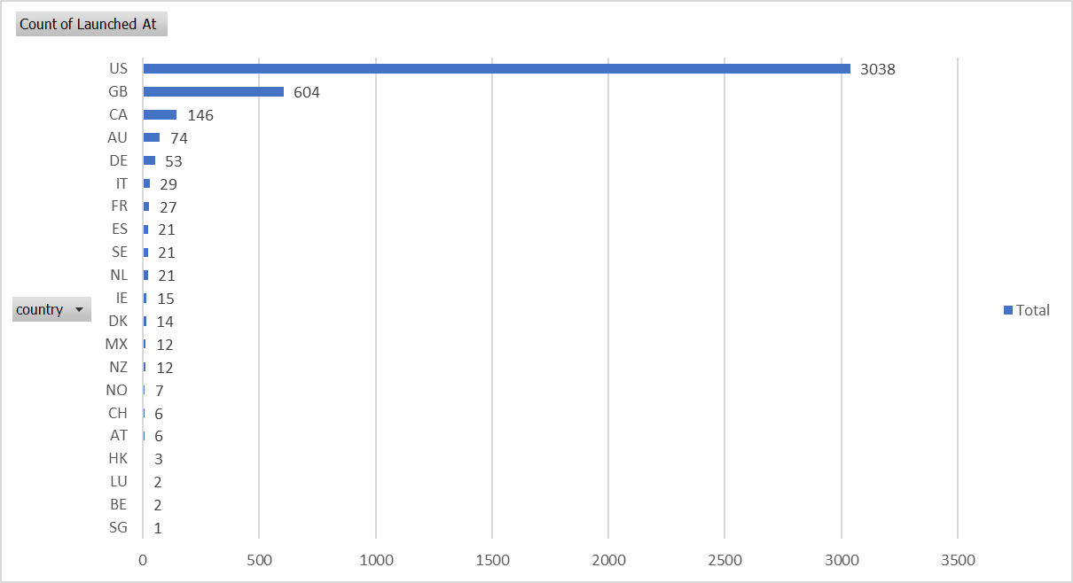

1. **What are some limitations of this dataset?**

I think that generally, the data is fairly robust, with no obvious issues with data quality or dirty/reliable data.

The main issue I have with this data is that there are multiple currency types in the data, therefore we are not able to compare any of the financial results – unless we were wanting to source some additional data to conduct lookups to identify the currency value on the donation date to covert back to a single currency type. For example, HKD to USD. There are sources available to do this, but we would not be able to do with current dataset.

1. **What are some other possible tables and/or graphs that we could create?**

A number of example charts we could use would include:

* *Doughnut Chart* to easily show top performing categories, subcategories etc.

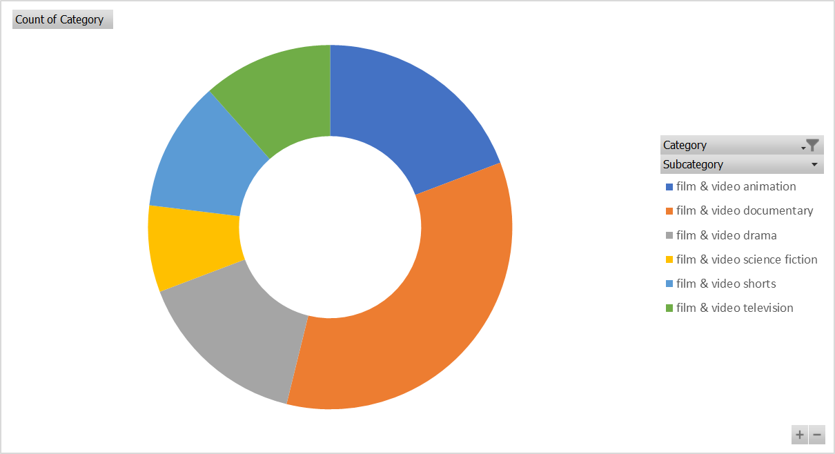

* Scatter Chart – Shows an analysis of the total backers and the total amount pledged. I note the data issues relating to currency, but this type of chart would be good to reflect this type of data.

* Line Chart – below is showing an shows an analysis of campaign result over the years. Is again is showing not only the annual results (year on year), it also shows how in 2014 – 2017 the number of campaigns run significantly increased.

* I would also significantly consider stacked column/bar charts, 2-axis bar/line charts (one of my personal favourites), as well as simple column charts.